Week 4
Hands on 2
Hello World RESTful Web Service :
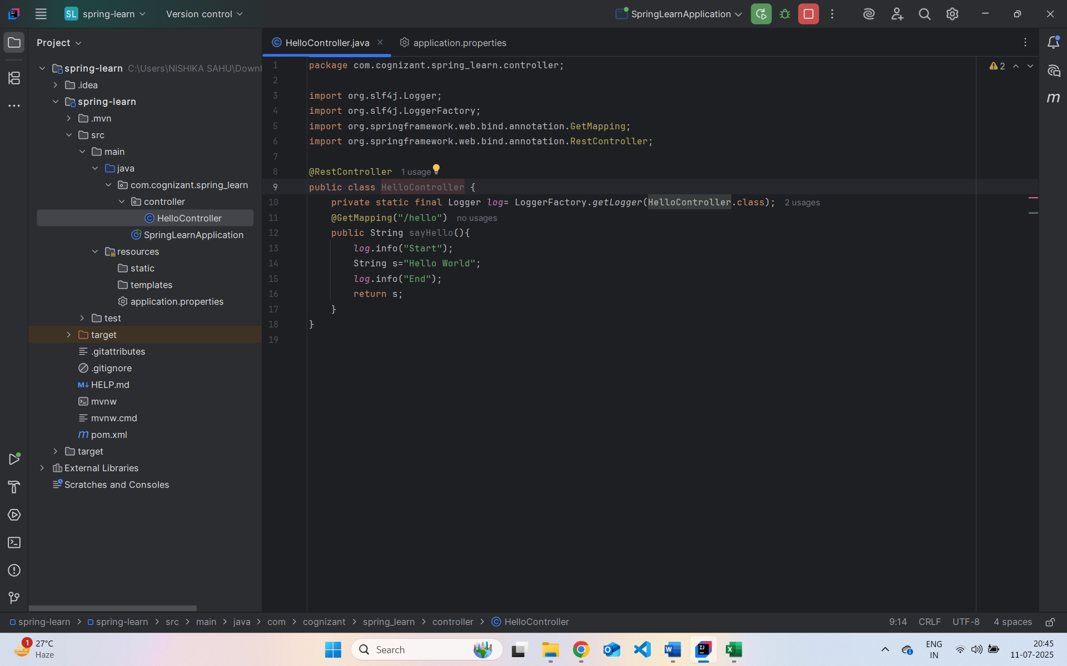
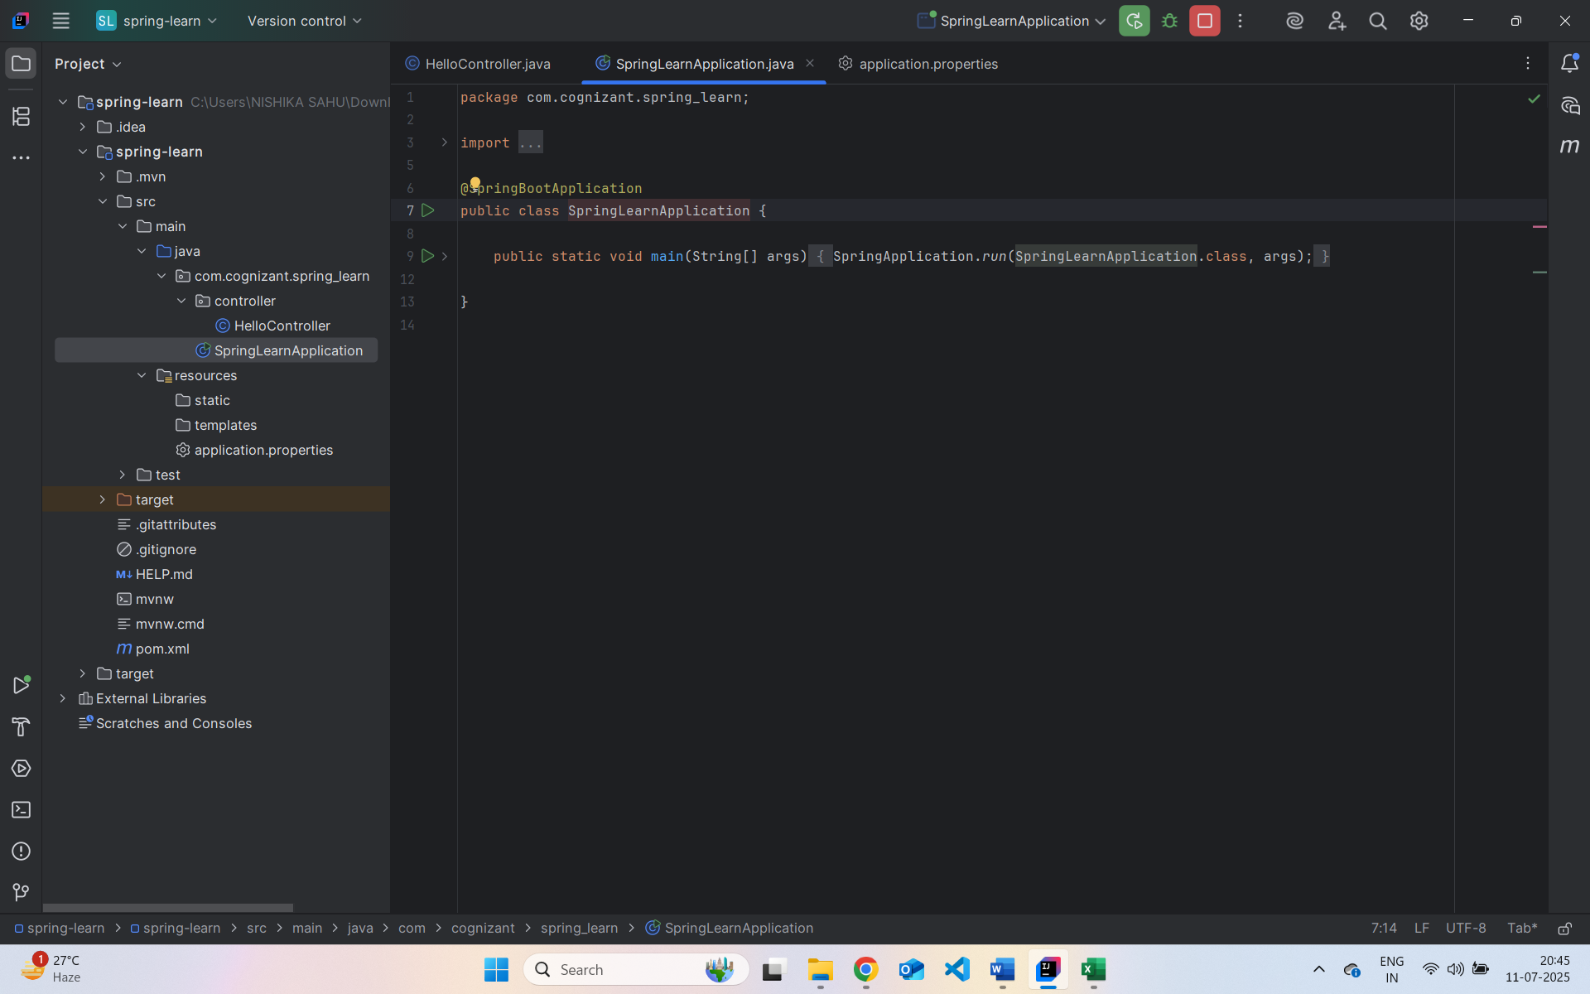
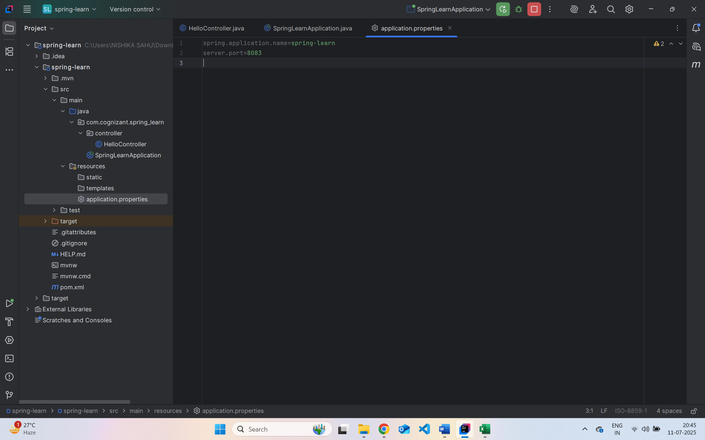
Output:
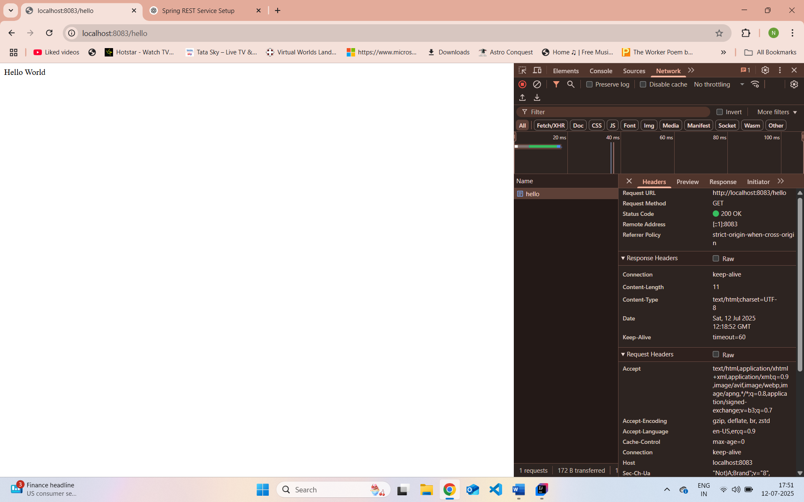
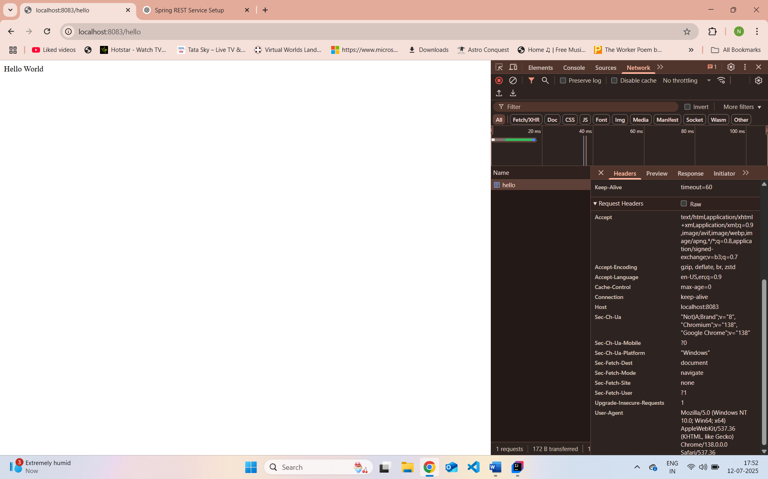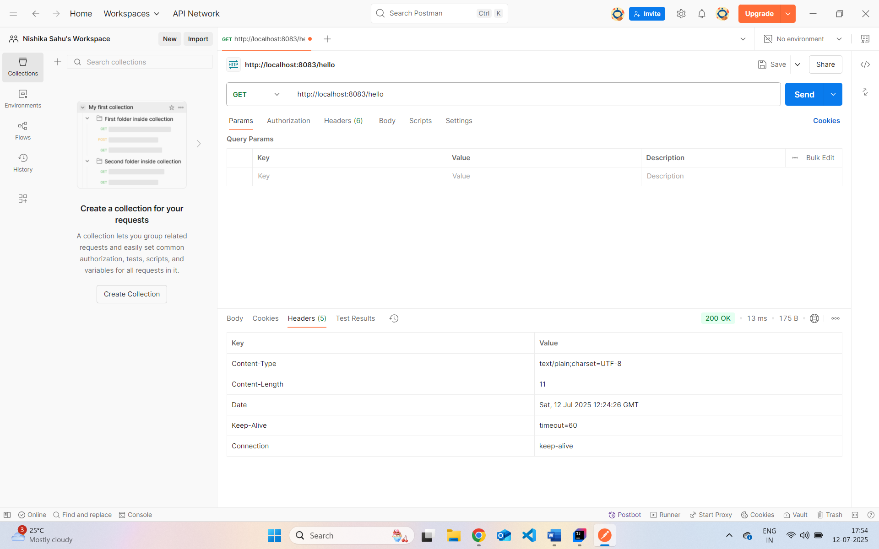

REST - Country Web Service :
com.cognizant.spring-learn.model.Country.java
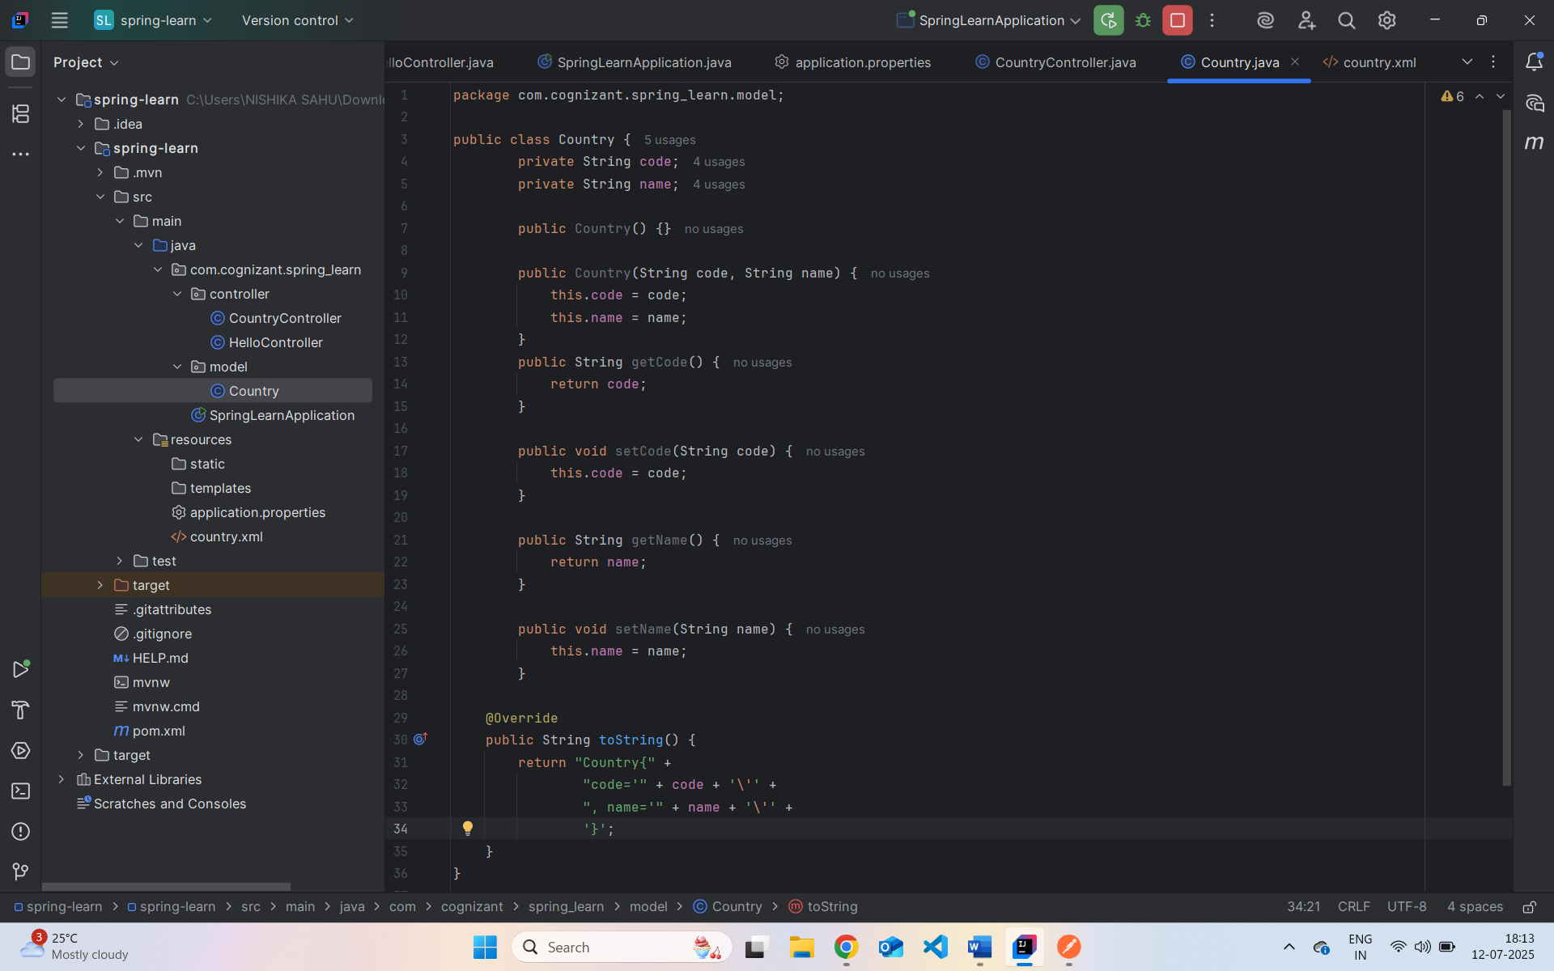
src/main/resources/country.xml
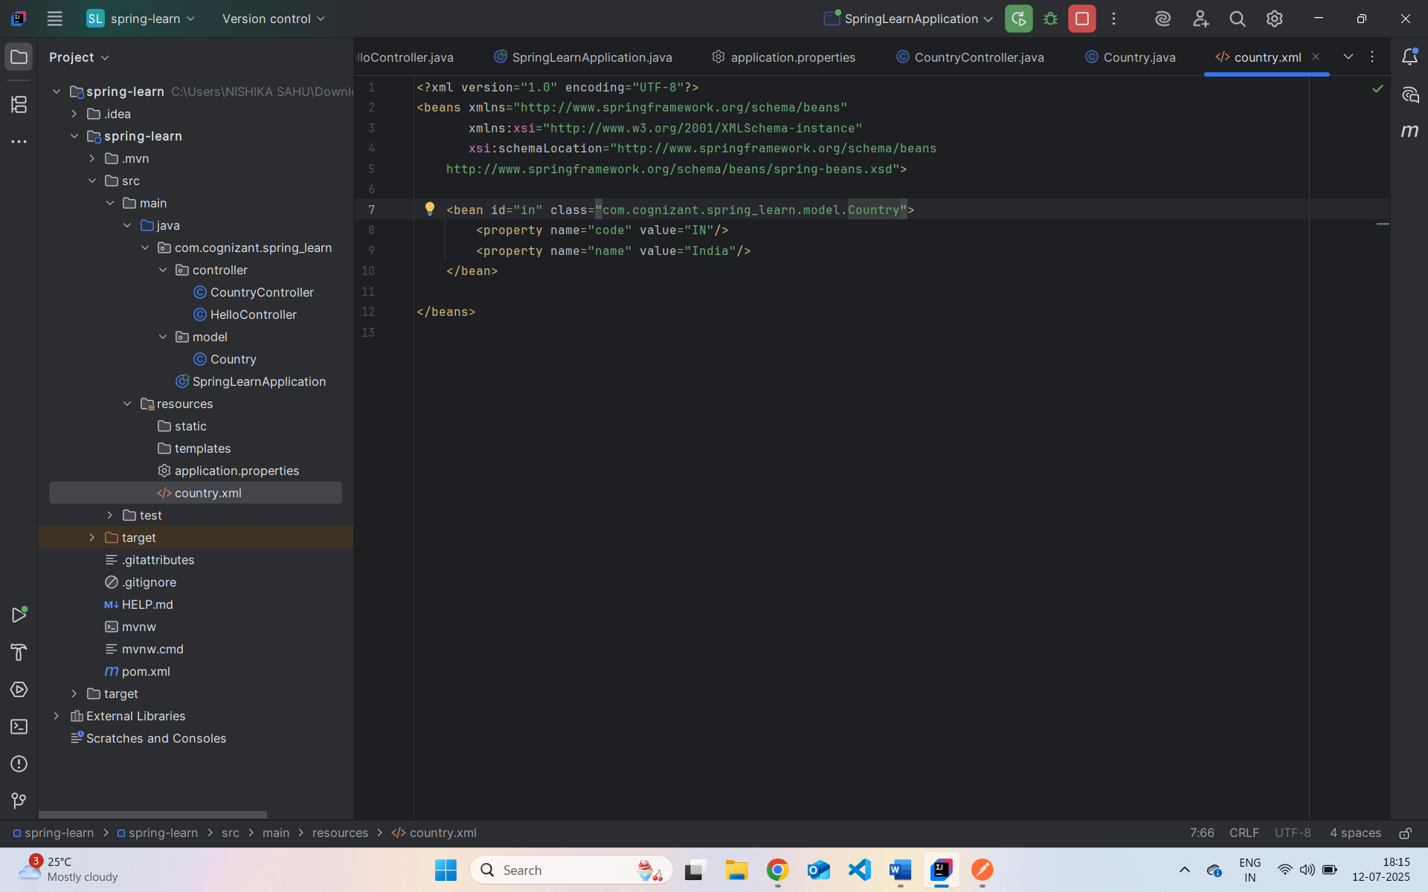
com.cognizant.spring-learn.controller.CountryController.java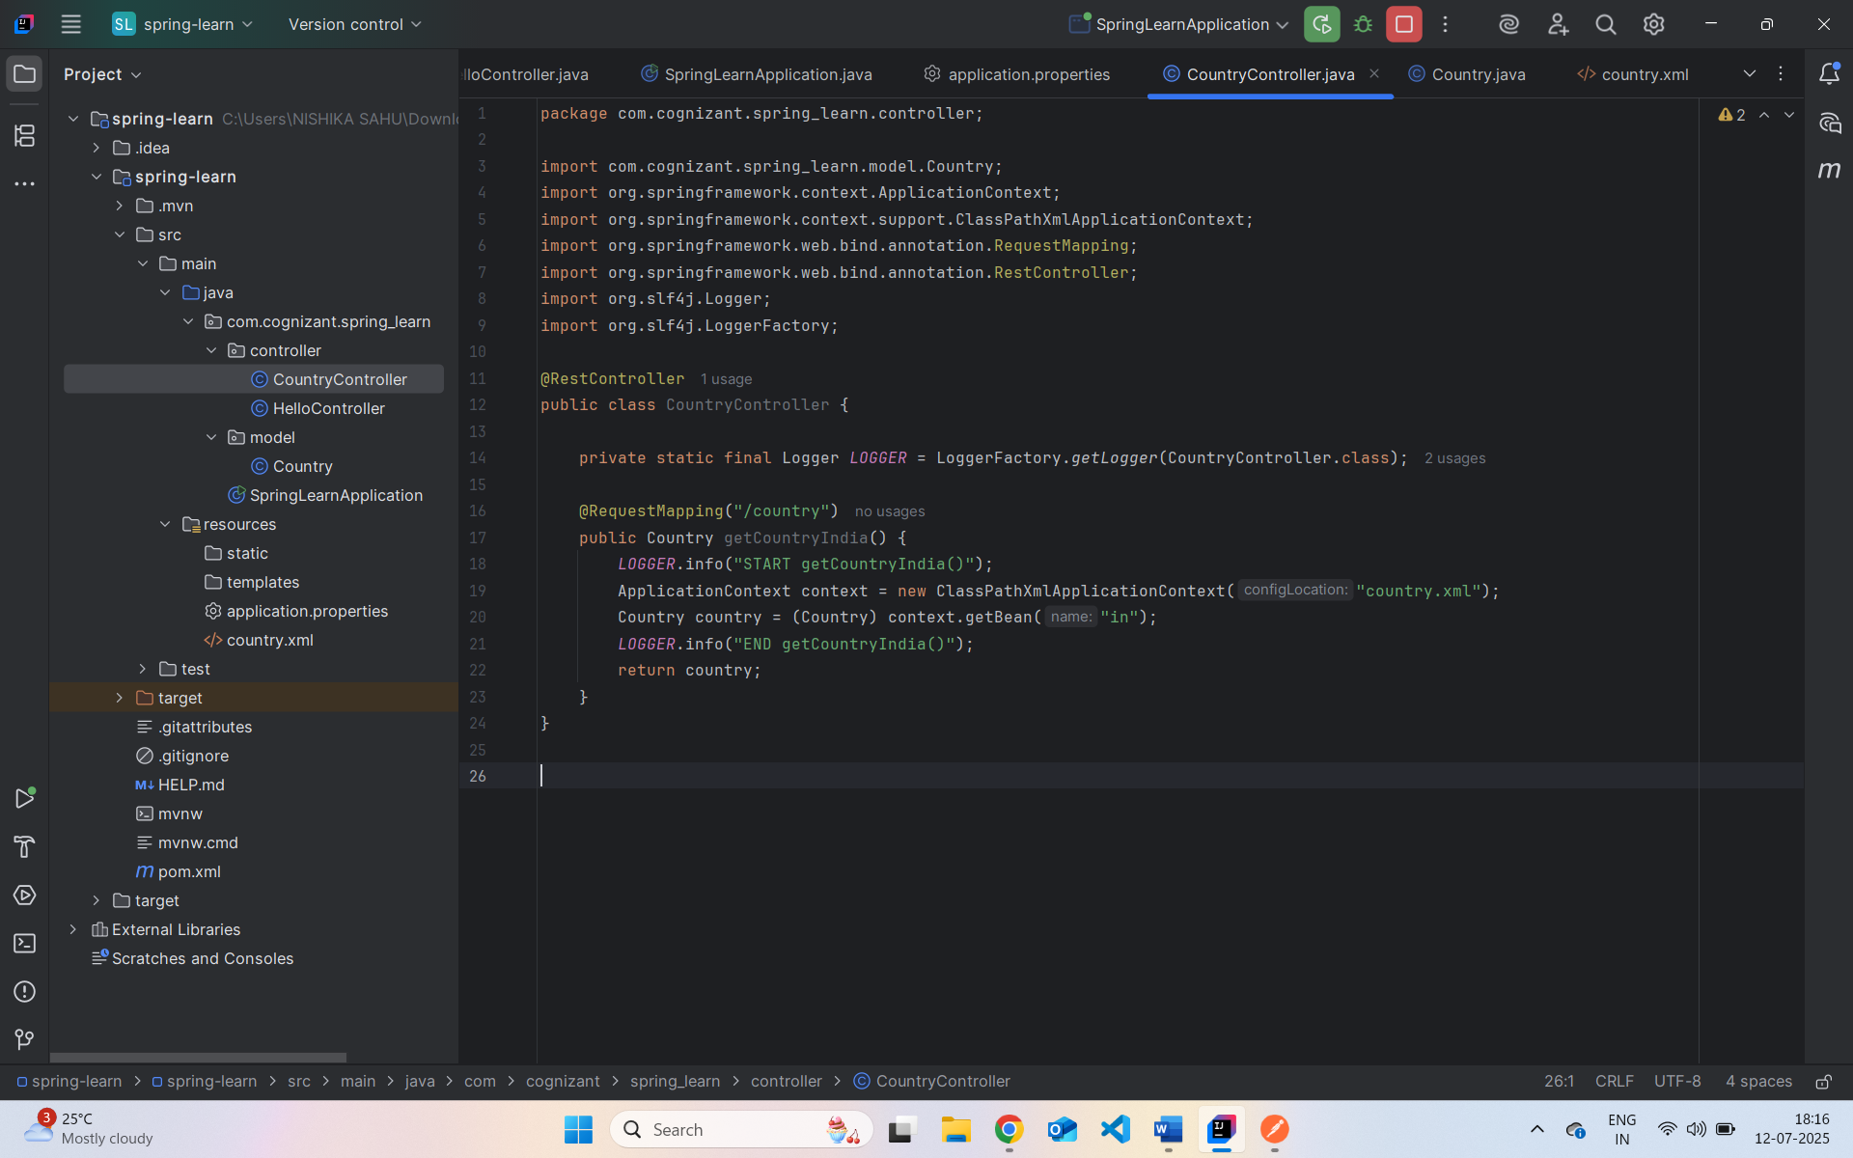
What happens in the controller method?
- A request to /country maps to the method getCountryIndia().
- The Spring ApplicationContext loads the bean configuration from country.xml.
- The in bean (India) is fetched and returned.
How is the Java bean converted to JSON?
- Spring Boot automatically uses Jackson (a JSON converter library).
- It detects that Country is a POJO and uses getters (getCode(), getName()) to convert it into a JSON response.
- This is done via @RestController, which combines @Controller and @ResponseBody, meaning return values are serialized directly to the response body (JSON by default).
In Chrome Developer Tools: 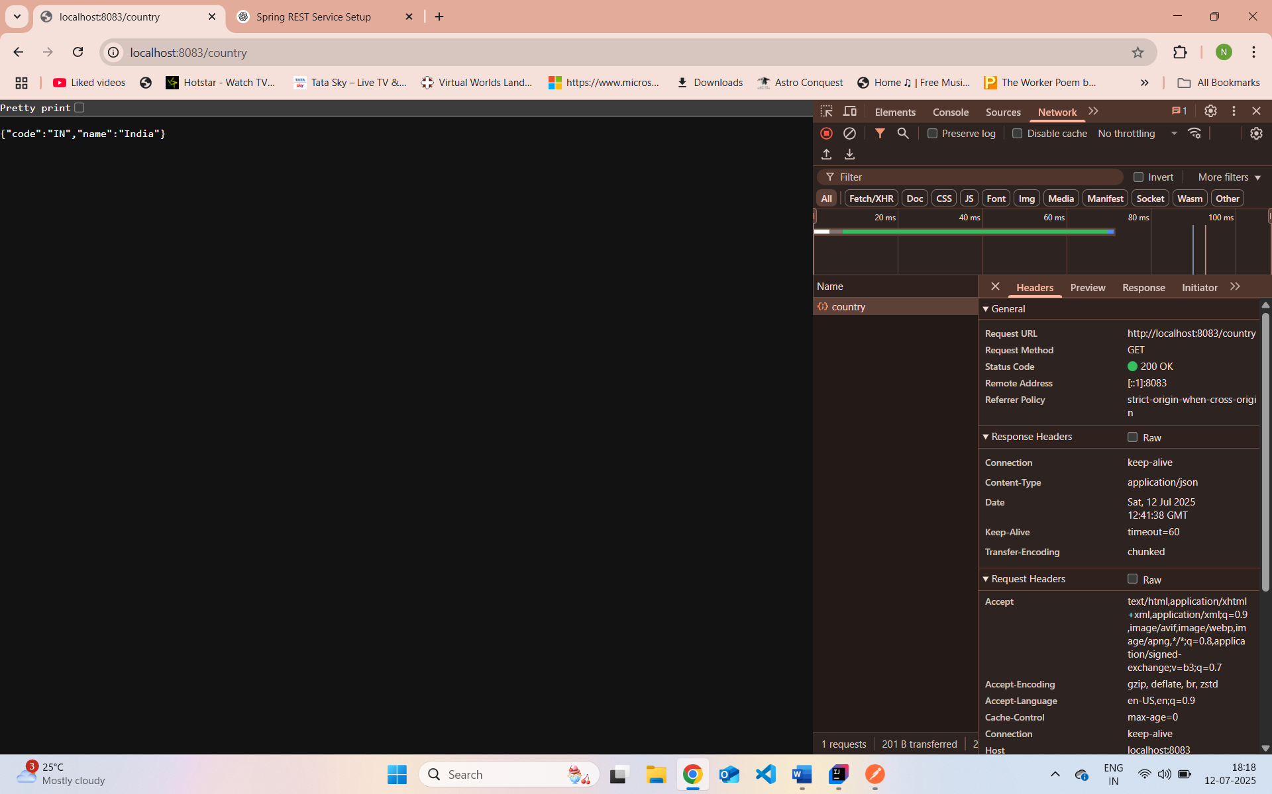

In Postman:
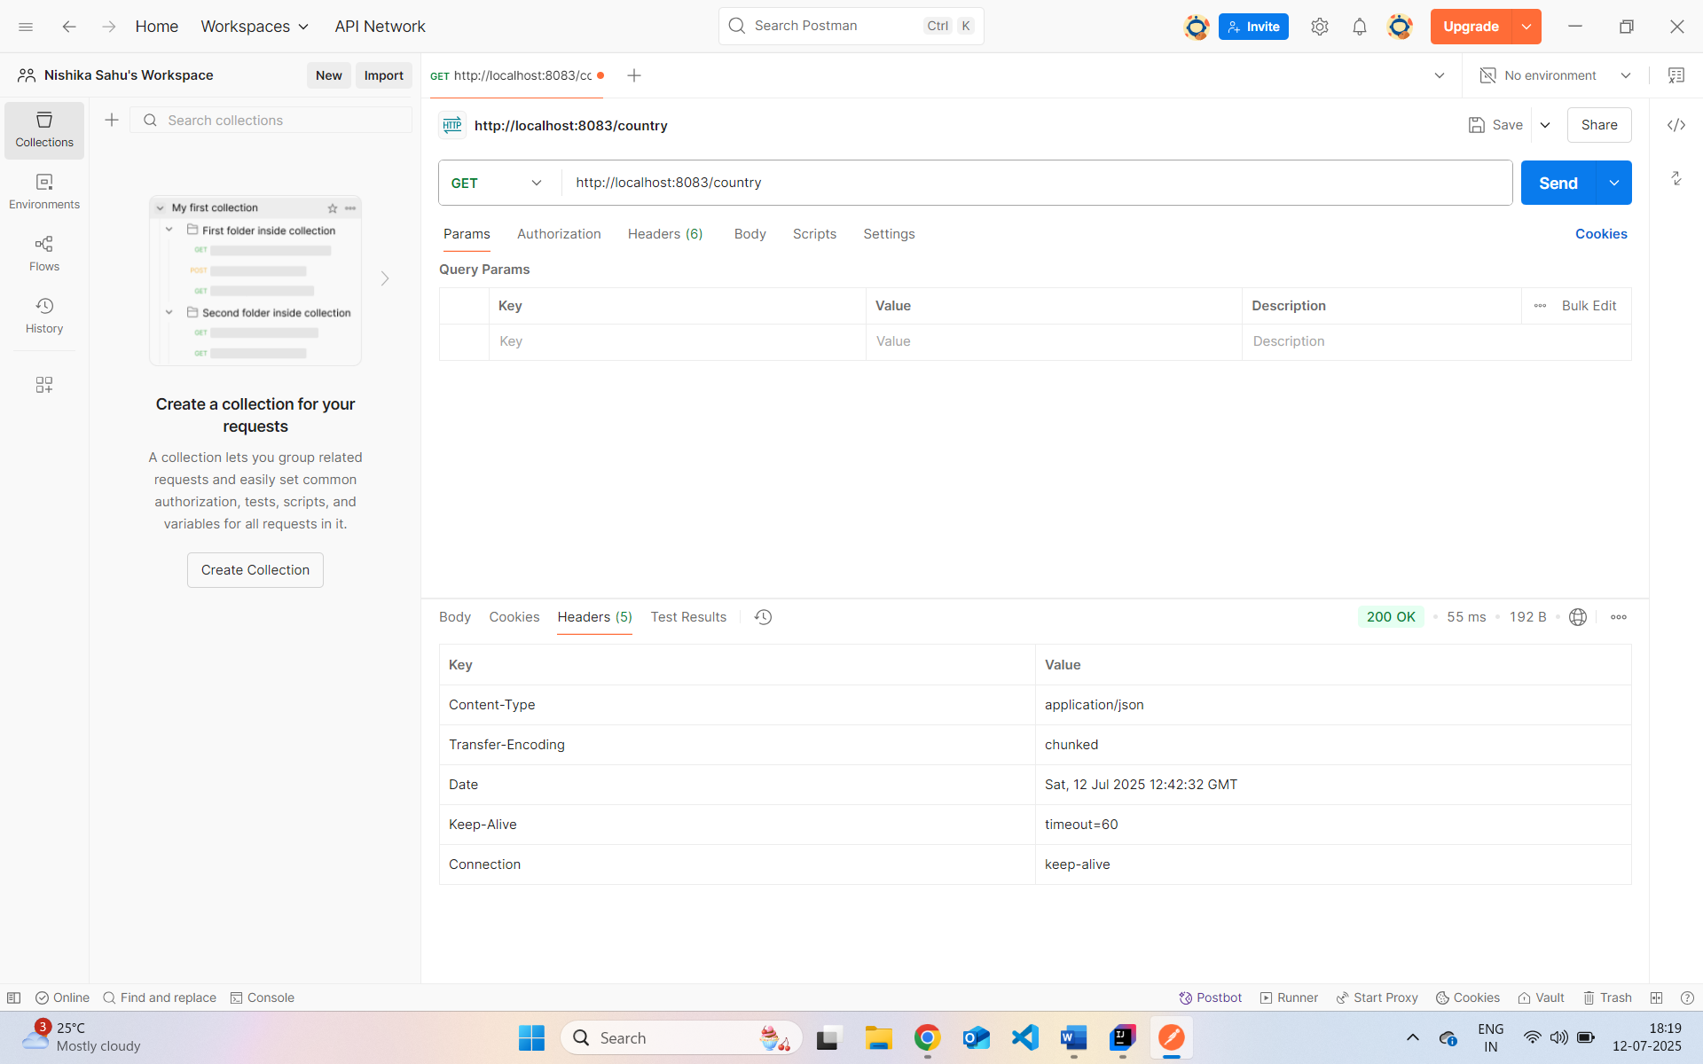
REST - Get country based on country code :
src/main/resources/country.xml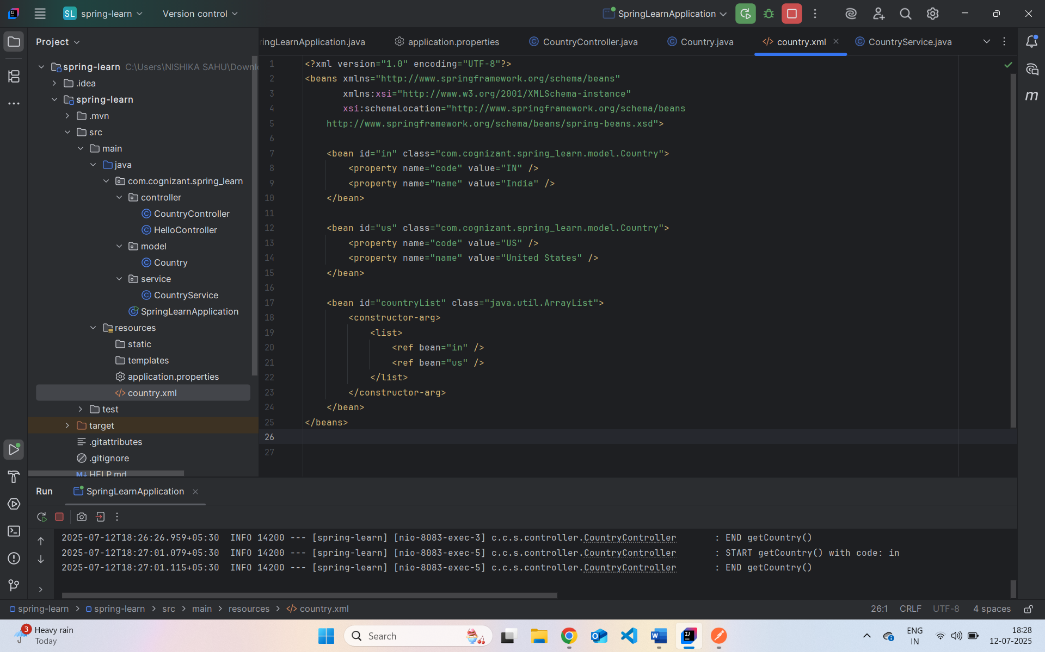
com.cognizant.spring_learn.service.CountryService.java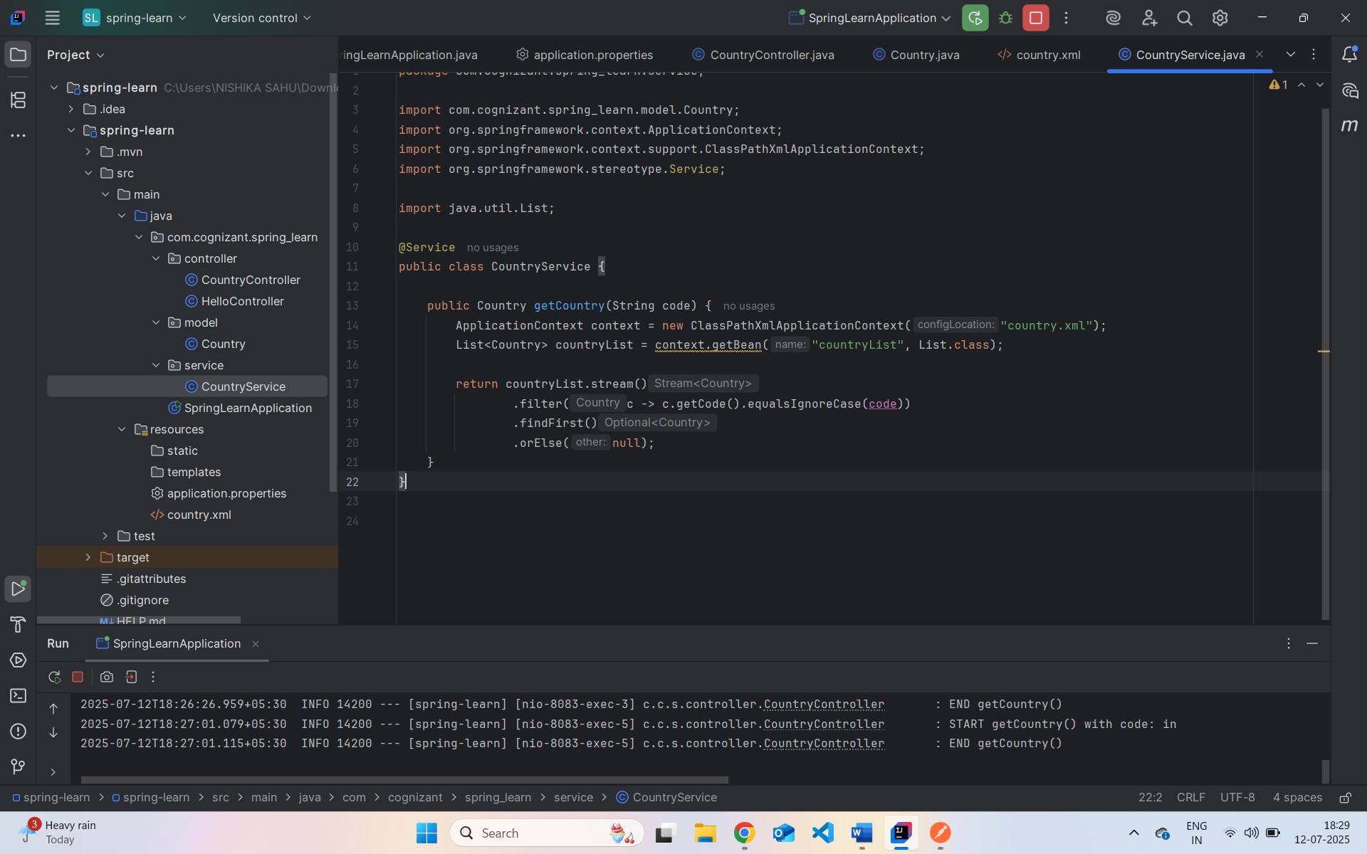
com.cognizant.spring_learn.controller.CountryController.java